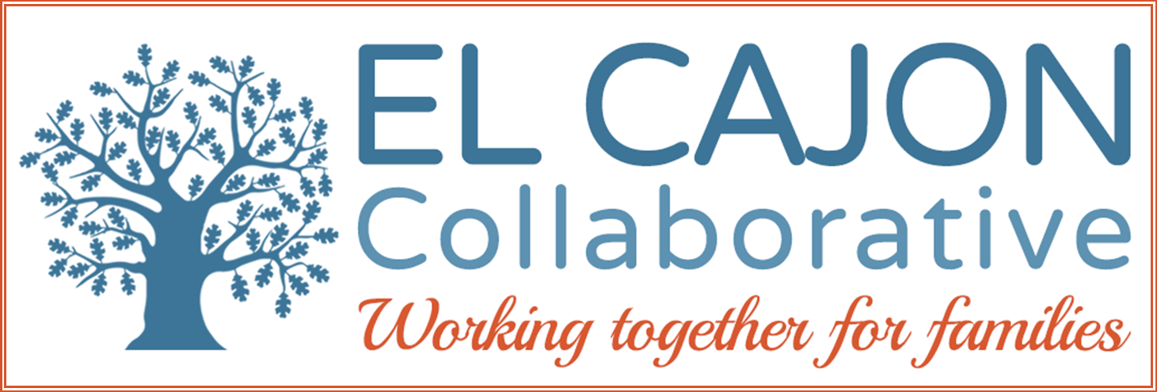

El Cajon Collaborative Council Meeting

April 3, 2018 / 12:30 – 2:00pm
Cajon Valley Union School District Board Room
750 E. Main St., El Cajon, CA 92020
Meeting Purpose:
To engage community members in resource sharing, networking, and action to benefit the children, youth and families of El Cajon

Meeting Agenda

Services for Refugees & Immigrants

Welcoming Remarks (5 minutes)

Please see the networking activity on the screen and share with your neighbor

II. Agency Highlight: (25 minutes)

Topic: Program Information

Program: Nile Sisters Development Initiative
Presenter: Danielle White

III. Presentation: (25 minutes)

Topic: Programs & Services

Program: Council on American-Islamic Relations, San Diego (CAIR)
Presenter: Mejgan Afshan, Advocacy & Policy Coordinator

IV. Presentation: (25 minutes)

Topic: Programs & Services

Program: Consulado General de México
Presenter: Patricia Pinzón, Cónsul de Asuntos Communitarios/Community Affairs

VI. Announcements and Sharing (10 minutes)

VII. Adjournment

2016-2020 Overall Strategic Focus
El Cajon Collaborative

Goals:
- Increase pro-social activities for children and youth:
  - Objective: Increase access to safe & healthy recreational opportunities
  - Objective: Increase opportunities for meaningful youth leadership and civic engagement.

- Increase community involvement in Collaborative partnerships:
  - Objective: Increase community engagement in self-sufficiency opportunities.
  - Objective: Increase community partnerships to support cultural inclusion.
  - Objective: Mobilize residents to proactively participate in community enhancement activities.

- Enhance prevention strategies using the public health model:
  - Objective: Advance opportunities to create safe, healthy and livable neighborhoods (universal)
  - Objective: Improve community health & wellness through resident engagement (secondary)
  - Objective: Increase culturally appropriate healthcare services (targeted)

- Increase advocacy efforts to support policies that:
  - Objective: Ensure safe, fair and affordable housing across the continuum of need;
  - Objective: Promote economic development to adequately ensure self-sufficiency;
  - Objective: Provide educational opportunities leading to career pathways;
  - Objective: Address community environments and norms to foster health.

