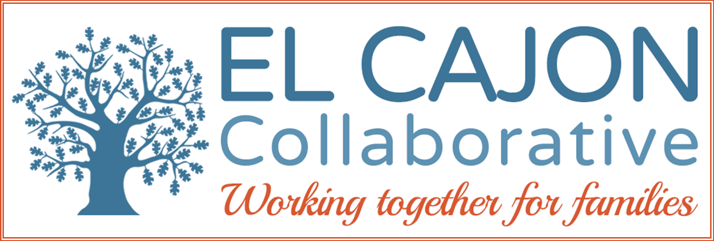

El Cajon Collaborative Council Meeting

April 5, 2016 / 12:30 – 2:00pm
Cajon Valley Union School District Board Room
750 E. Main St., El Cajon, CA 92020
Meeting Purpose:
To engage community members in resource sharing, networking, and action to benefit the children, youth and families of El Cajon

Youth Mental Health Services Agenda

Welcoming Remarks & Introductions: (5 minutes)

Newcomer’s Collaborative Workgroup Report: (5 minutes)

Presenter: Mohammed Tuama, Chair

Presentation: (20 minutes)

Topic: School Based Youth Behavioral Health Program

Program: Rady Children’s Hospital Behavioral Health Clinic

Presenter: Gary Youssef, MFT Clinic Supervisor

Presentation: (20 minutes)

Topic: County Based Youth Behavioral Health Program

Program: Rady Children’s Hospital Behavioral Health Clinic

Presenter: George Montoya, MFT Program Coordinator School-Based Program

V. Presentation: (20 minutes)

Topic:

Program:
Presenter:

VI. Presentation: (0 minutes)

Topic:

Program:
Presenter:
Next Meeting:
Tuesday, May 7, 2016
12:30-2:00pm
Cajon Valley Union School District (Board Room)
750 E. Main St., El Cajon
Bring your sack lunch.

VII. Announcements: (10 minutes)
Group Discussion

El Cajon Collaborative Strategic Work Priorities
Overall Strategic Focus: Public Safety and Youth

Goals:
- Increase pro-social activities for youth
  - Objective A: Engage community into recreation facilities and activities
  - Objective B: Seek opportunities for mentoring our youth

- Increase community involvement in Collaborative partnerships
- Objective A: Mobilize residents to proactively participate in public safety activities

- Enhance prevention activities for youth using the public health model of universal, secondary and targeted interventions.
  - Objective A: Improve community wellness
  - Objective B: Increase community partnerships to prevent bullying and provide character education.

***Measurable outcomes will be determined for each objective through Core Team.

